EE-254 OP-AMP CHARACTERISTICS

SAMARAKOON S.M.O.T.

E/21/345

SEMESTER 4

GROUP EE.21.30.

30/06/2025

1. Voltage follower

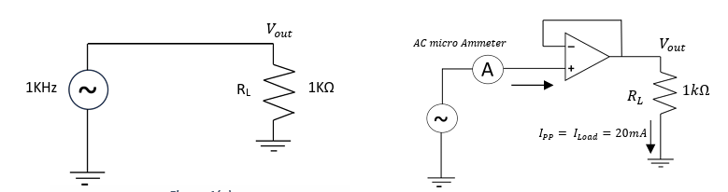

FIGURE 1(b)

FIGURE 1(a)

1. Apply a 1 kHz sinusoidal signal to the 1k load shown in Figure 1(a)

***Note: Make sure the signal generator output amplitude is at its minimum***.

2.Now increase the signal generator output amplitude until you get 20 mA peak-to-peak current through the load resistor RL .   
*Hint: Measure the ac-voltage across RL , instead of measuring the current through it. This will allow you to find the peak-to-peak current through the load resistor without the aid of an ammeter. You can use multi-meter for this purpose, remember that it shows you the RMS value of the voltage when put it into the ac mode.*

3. From the data you obtained from step 2, find the peak value of the current drawn from the signal source for step 2.

Voltage across RL (multimeter reading),

$$I=\frac{V}{R}$$

$$20 mA=\frac{V_{pp}}{1 kΩ}$$

$V_{pp}$ = 20 V

$$V_{rms}=\frac{V_{pp}}{2\sqrt{2}}$$

$$V_{rms}=7.07 V$$

Voltage at the signal generator output,

$${ V}_{p}=10.37 V$$

The current drawn from the signal generator output,

$$I=\frac{V}{R}$$

$$I_{p}=\frac{10.37 V}{1 kΩ}$$

$I_{p}$ = 10. 37 mA

4. Now connect the circuit shown in Figure 1(b).   
 ***Note: Make sure you that you have adjusted the signal generator amplitude to its minimum before you connect the circuit.***

5. Using a 1 kHz sinusoidal signal, repeat step2.

b) Input Offset Voltage

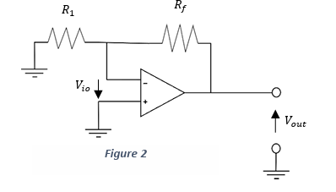

I1 A I2

I

B

FIGURE 2

1. Derive an expression for Vout in terms of Vio, Rf and R1.

Since op-amp has high input impedance, I = 0

KCL to node A,

$$I_{1}=I_{2}+I$$

$I_{1}= I_{2} ( ∵I=0)$

$$\frac{0-V_{A}}{R_{1}}= \frac{V_{A}- V_{out}}{R_{f}}$$

$\frac{V_{out}}{R_{f}}= V_{A}\left(\frac{1}{R_{f}}+ \frac{1}{R_{1}}\right)$

$V_{A} = \frac{R_{1}}{R_{f}+ R_{1}} V_{out}$

Since,

(VB = 0)

2. Connect the circuit by taking Rf=100kΩ and R₁=100Ω.

3. Measure the output voltage with respect to the ground. Hence calculate the Input Offset Voltage of the Op - Amp.

Vout =2.05V

Vio = 2.05V×($\frac{100}{100×{10}^{3}+ 100}$)

Vio  = 2.048 mA

(c) Frequency Response

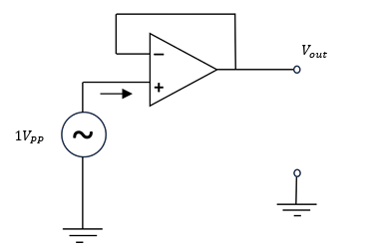

FIGURE 3

URE 2

1. Connect the unity gain buffer circuit as shown in Figure 2.
2. Apply a 1V peak to peak sinusoidal signal to the non-inverting terminal.
3. Measure the input signal amplitude and the output signal amplitude for the following frequencies. Also measure the phase difference between input and output signals. (20Hz 50Hz 100Hz 200Hz 500Hz kHz 5kHz 50kHz 100kHz 200kHz 500kHz.)

***Note: You have to check and make sure amplitude of the signal generator output is at 1V peak to peak for each and every frequency mentioned above***.

TABLE 1: INPUT SIGNAL VOLTAGE, OUTPUT SIGNAL VOLTAGE,AND PHASE

DIFFERENCE BETWEEN INPUT AND OUTPUT SIGNALS

|  |  |  |  |  |
| --- | --- | --- | --- | --- |
| Frequency | Input Signal Peak to Peak (V) | Output Signal Peak to Peak (V) | Gain | Phase Difference  (degreess) |
| 20 Hz | 1.03 | 1.07 | 1.04 | -1.44 |
| 50 Hz | 1.03 | 1.07 | 1.04 | -3.60 |
| 100 Hz | 1.05 | 1.03 | 0.98 | -2.88 |
| 200 Hz | 1.05 | 1.03 | 0.98 | 0.76 |
| 500 Hz | 1.05 | 1.03 | 0.98 | 1.80 |
| 1 kHz | 1.05 | 1.03 | 0.98 | 5.60 |
| 5 kHz | 1.05 | 1.03 | 0.98 | 6.82 |
| 10 kHz | 1.05 | 1.03 | 0.98 | 6.82 |
| 50 kHz | 0. 99 | 0.99 | 1.00 | 35.25 |
| 100 kHz | 0. 99 | 0.99 | 1.00 | 46.80 |
| 200 kHz | 0. 99 | 0.88 | 0.89 | 53.65 |
| 500 kHz | 0. 99 | 0.36 | 0.36 | 78.88 |

1. Then obtain the frequency response of the Op-Amp by plotting the Gain Response and the Phase Response

TABLE 2: VARIATION OF LOG(FREQUENCY) VS VOLATGE GAIN

|  |  |
| --- | --- |
| log(frequency) | Voltage Gain |
| 1.30 | 1.04 |
| 1.70 | 1.04 |
| 2.00 | 0.98 |
| 2.30 | 0.98 |
| 2.70 | 0.98 |
| 3.00 | 0.98 |
| 3.70 | 0.98 |
| 4.00 | 0.98 |
| 4.70 | 1.00 |
| 5.00 | 1.00 |
| 5.30 | 0.89 |
| 5.70 | 0.36 |

TABLE 3: VARIATION OF LOG(FREQUENCY) VS PHASE DIFFERENCE

|  |  |
| --- | --- |
| log(frequency) | Phase Difference (degrees) |
| 1.30 | -1.44 |
| 1.70 | -3.60 |
| 2.00 | -2.88 |
| 2.30 | 0.76 |
| 2.70 | 1.80 |
| 3.00 | 5.60 |
| 3.70 | 6.82 |
| 4.00 | 6.82 |
| 4.70 | 35.25 |
| 5.00 | 46.80 |
| 5.30 | 53.65 |
| 5.70 | 78.88 |

(d) Input Bias Current and Input Offset Current

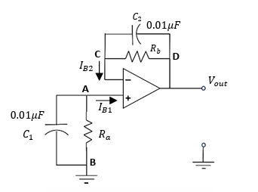

FIGURE 6

1. Connect the circuit as shown in Figure 5.

***Note: Choose 𝑹𝒂 = 𝑹𝒃 > 10MΩ. Normally the input bias current 𝑰𝑩, is in the range 100nA. So higher values of 𝑹𝒂 𝒂𝒏𝒅 𝑹𝒃 will ensure that 𝑰𝑩𝑹𝒃 > 𝑽𝒊𝒐 so that the voltages created by bias currents are much greater than 𝑽𝒊𝒐.***

1. What is the value of Vout when the terminals A and B are short circuited?

Measure the value of Vout for this condition and calculate the value of IB2.

1. What is the value of Vout when the terminals C and D are short circuited?

Measure the value of Vout for this condition and calculate the value of IB1.

1. From the values of IB1 and IB2, calculate the value of input bias current IB.

nA

$= 6.25 nA$

1. Find an expression for the input offset current in terms of IB1 and IB2 and find the input offset current of the Op-Amp used.

$Input Offset Current= {| I}_{B1}- I_{B2} |$

$=\left| 2.77- 9.73 \right|nA$

$=6.96 nA$

(e) Slew Rate

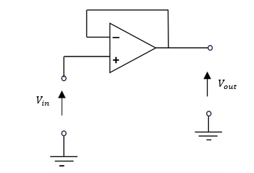

FIGURE 7

1. Connect the unity gain buffer circuit as shown in Figure 6.
2. Apply a 3V peak to peak sinusoidal signal to the non-inverting terminal.
3. Observe the output waveforms for the following frequencies.  
    20Hz 50Hz 100Hz 200Hz 500Hz 1kHz 5kHz 10kHz 50kHz 100kHz 200kHz 500kHz.  
    Explain in your own words what you have observed.  
    ***Hint: Consider changes of waveform shape, amplitude etc***.

TABLE 4: INPUT SIGNAL VOLTAGE AND OUTPUT SIGNAL VOLTAGE FOR DIFFERENT FREQUENCIES OF SINUSOIDAL SIGNAL

|  |  |  |
| --- | --- | --- |
| Frequency | Input Voltage Peak to Peak (V) | Output Voltage Peak to Peak (V) |
| 20 Hz | 3.00 | 3.21 |
| 50 Hz | 3.00 | 3.21 |
| 100 Hz | 3.00 | 3.11 |
| 200 Hz | 3.00 | 3.13 |
| 500 Hz | 3.00 | 3.13 |
| 1 kHz | 3.00 | 3.13 |
| 5 kHz | 3.00 | 3.09 |
| 10 kHz | 3.00 | 3.11 |
| 50 kHz | 3.00 | 3.01 |
| 100 kHz | 3.00 | 1.96 |
| 200 kHz | 3.00 | 1.00 |
| 500 kHz | 3.00 | 0.38 |

At low frequencies, the Op-Amp easily amplifies signals clearly, matching the input without distortion. But as frequency rises, it struggles, output signals start to distort and gain drops, showing its limitation at handling higher frequencies.

1. Now apply 6V peak to peak square wave signal to the non-inverting terminal.
2. Observe the output waveforms for the following frequencies.  
    20Hz 50Hz 100Hz 200Hz 500Hz 1kHz 5kHz 10kHz 50kHz 100kHz 200kHz 500kHz.  
    ***Note: You have to check and make sure that the amplitude of the signal generator output is at V peak-to-peak for each and every frequency mentioned above.***
   1. At the rising edge of the input waveform, find the time it takes for the output signal to reach its peak value.
   2. At the falling edge of the input waveform, find the time it takes for the output signal to reach its lowest value.
   3. Then calculate the time rate of change of the closed loop amplifier output voltage for each of above frequencies for both rising edge and falling edge cases.

TABLE 5: RISE TIME, FALL TIME, INPUT SIGNAL AMPLITUDE, OUTPUT SIGNAL AMPLITUDE AND RATE OF CHANGE OF OUTPUT VOLTAGE FOR RISING EDGE AND FALLING EDGE CASES

|  |  |  |  |  |  |  |
| --- | --- | --- | --- | --- | --- | --- |
| Frequency | Rise Time (µs) | Fall Time (µs) | Input Voltage Peak to Peak (V) | Output Voltage Peak to Peak (V) | Time rate of change (V/µs) | |
| Rising Edge | Falling Edge |
| 20 Hz | 12 | 12 | 6 | 6.00 | 0.5 | 0.5 |
| 50 Hz | 12 | 12 | 6 | 6.00 | 0.5 | 0.5 |
| 100 Hz | 14 | 12 | 6 | 6.10 | 0.4357 | 0.5083 |
| 200 Hz | 14 | 10 | 6 | 6.00 | 0.4285 | 0.6 |
| 500 Hz | 11.2 | 11 | 6 | 6.00 | 0.5357 | 0.5454 |
| 1 kHz | 11.2 | 10.6 | 6 | 6.00 | 0.5357 | 0.5660 |
| 5 kHz | 10.92 | 10.32 | 6 | 6.00 | 0.5494 | 0.5813 |
| 10 kHz | 10.86 | 10.26 | 6 | 6.00 | 0.5524 | 0.5847 |
| 50 kHz | 7.99 | 7.81 | 6 | 4.30 | 0.5381 | 0.5505 |
| 100 kHz | 3.93 | 3.88 | 6 | 2.13 | 0.5419 | 0.5489 |
| 200 kHz | 2.10 | 1.99 | 6 | 1.13 | 0.5381 | 0.5678 |
| 500 kHz | 0.744 | 0.745 | 6 | 0.46 | 0.6182 | 0.6175 |

* 1. Then find the maximum rate of change of the output voltage, hence find the slew rate of the device. ***Hint: It is the usual practice to specify the slower of the two rates (rising edge case or falling edge case) as the slewing rate of the device***
* Rate of change of the output voltage = $\frac{Output Voltage(V)}{Rising or Falling time(µs)}$
* Maximum rate of change of the output voltage = 0.6182 V/µs
* Slew Rate of the device = Slower rate of change of output voltage in rising and falling edge case

= 0.4285 V/µs

1. Comment on the waveform shapes you observed at the output for higher frequencies.

At higher frequencies, the output waveform becomes distorted, losing its original shape. Edges start rounding off, and you might see overshoot or undershoot, where the signal rises higher or dips lower than intended. This distortion happens because the Op-Amp's bandwidth and slew rate limit its ability to keep up with rapid input changes. When these limits are hit, the Op-Amp can't accurately track the input, making it unsuitable for high-speed signals unless chosen carefully based on the application's requirements.

REFERENCES

[1] Texas Instruments, "UA741 Operational Amplifier Datasheet," Texas Instruments, Dallas, TX, USA. [Online]. Available: https://www.ti.com/lit/ds/symlink/ua741.pdf.  
 [Accessed: June 30, 2025].

[2] T. L. Floyd, Electronic Devices, 9th ed., Upper Saddle River, NJ, USA: Pearson Education, 2014.

[3] A. S. Sedra and K. C. Smith, Microelectronic Circuits, 8th ed., New York, NY, USA: Oxford Univ. Press, 2019.

[4] S. Franco, Design with Operational Amplifiers and Analog Integrated Circuits, 4th ed., New York, NY, USA: McGraw-Hill Education, 2014.